FTCP Simulator Install Guide

# Introduction

FTCP Simulator is a MQTT client, which can connect to any MQTT broker/Broker alike (Which can act like a broker) and simulate the behaviors of a TCU or SDN in MQTT standpoint.

# Components required to run FTCP simulator

* FTCP simulator application: It’s a Windows Forms based application.
* FTCP protobuf message Assembly: This library contains the FTCP protobuf definitions.
* Vehicle data decoder maps (VDD maps): These contain information required to decode different CAN signals emitted from vehicle that are bundled into FTCP messages.
* XML message sets: These contain sample XML messages (One per valid FTCP message type).

These Xml messages can be loaded to FTCP simulator UI and publish.

# Download locations:

FTCP simulator:

<https://it.extspt.ford.com/sites/ngsdn/Reference%20Material%20and%20Resources/Forms/AllItems.aspx?RootFolder=%2Fsites%2Fngsdn%2FReference%20Material%20and%20Resources%2FFTCPSim%2DDistro&FolderCTID=0x01200086800A916C858C4FA4EC43EBECFD122C&View=%7BC777F6A9%2D28FE%2D4B09%2DB775%2D8A44DD4A265F%7D>

FTCP protobuf message assembly:

<https://it.extspt.ford.com/sites/ngsdn/Reference%20Material%20and%20Resources/Forms/AllItems.aspx?RootFolder=%2Fsites%2Fngsdn%2FReference%20Material%20and%20Resources%2FFTCPSim%2DProtobuf%2DMessage%2DAssemblies&FolderCTID=0x01200086800A916C858C4FA4EC43EBECFD122C&View=%7BC777F6A9%2D28FE%2D4B09%2DB775%2D8A44DD4A265F%7D>

Vehicle data decoder maps:

<https://it.extspt.ford.com/sites/ngsdn/Reference%20Material%20and%20Resources/Forms/AllItems.aspx?RootFolder=%2Fsites%2Fngsdn%2FReference%20Material%20and%20Resources%2FVDD%2DMap%2DDistro&FolderCTID=0x01200086800A916C858C4FA4EC43EBECFD122C&View=%7BC777F6A9%2D28FE%2D4B09%2DB775%2D8A44DD4A265F%7D>

Xml messages sets:

<https://it.extspt.ford.com/sites/ngsdn/Reference%20Material%20and%20Resources/Forms/AllItems.aspx?RootFolder=%2Fsites%2Fngsdn%2FReference%20Material%20and%20Resources%2FFTCPSim%2DXML%2DMessage%2DSets&FolderCTID=0x01200086800A916C858C4FA4EC43EBECFD122C&View=%7BC777F6A9%2D28FE%2D4B09%2DB775%2D8A44DD4A265F%7D>

These locations contain different released versions. **Please take the latest dated files.**

# Pre-requisites to use FTCP simulator:

* .Net Framework 4.6
* Visual C++ 2012 x64 redistributable

# FTCP simulator Install Instructions:

Download all the above-specified zip files and keep them extracted.

Note: Better, keep all the extracted folders in same location for ease of access.

Go to folder ‘FTCPSim-Distro-XXXXXXXXX’ from downloaded folders and run ‘FTCPSimApp.application’ or ‘setup.exe’.

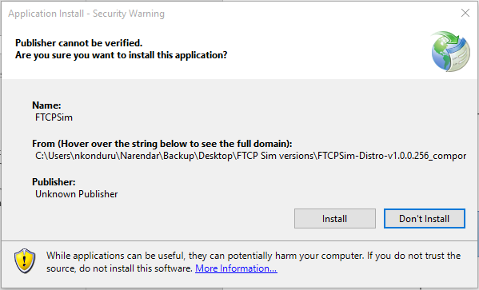

Click Install, Application will be installed and open as shown below.

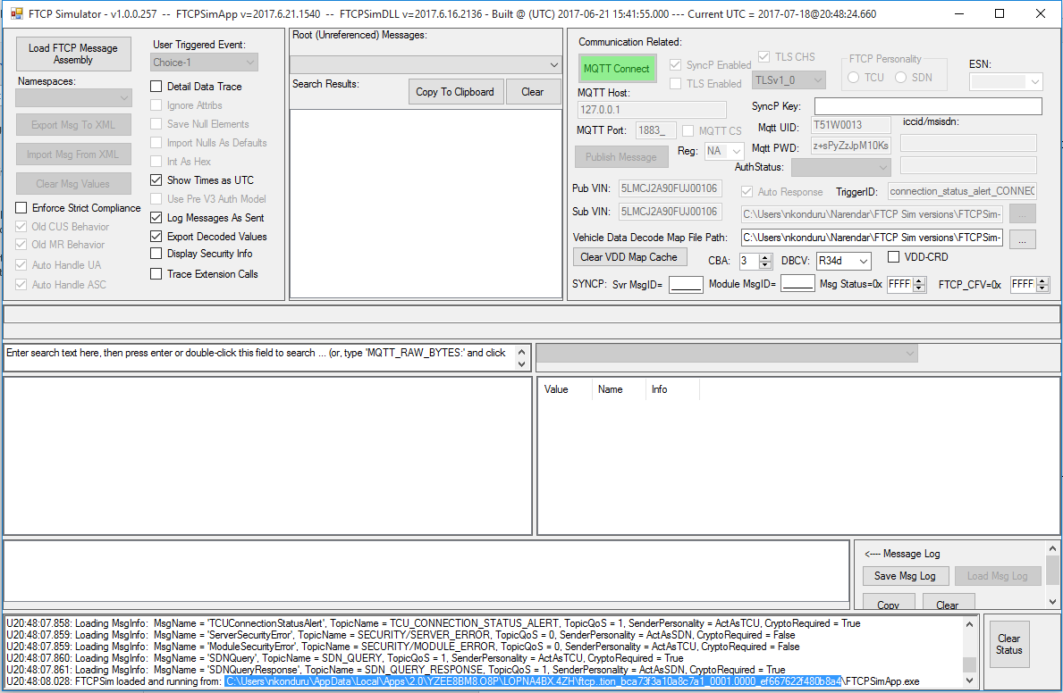

The highlighted line in blue (The last line in status window, for each new instance of FTCP simulator created) shows the FTCP sim install path (Where FTCP simulator is installed on the machine). Application will show this path each time it Run.

Note: By default, the FTCP simulator application will install in ‘local App data’ folder on the machine.